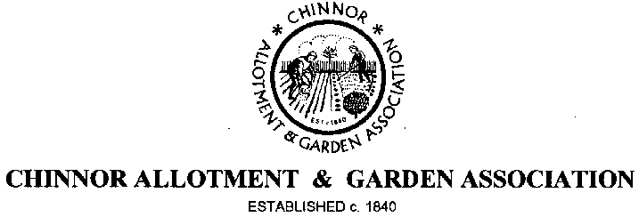

Annual General Meeting
8.00 PM Wednesday 11th October, 2017
The Chiltern Room
Chinnor Village Centre, High Street, Chinnor

The Association will be holding its Annual General Meeting as above and you are cordially invited. This is your opportunity to have your say, both complimentary and critical and to discuss how you would like to see the Association develop over the coming years. So please make every effort to attend.
Please find attached the minutes of last year’s AGM and this year’s Agenda.
Annual Plot rents become due from 1st October and you will be required to pay by the end of October 2017, otherwise your plot may be deemed vacant and re-let, so please make every effort to visit the Distribution Centre any Sunday between 10.00 am and 12 noon before the end of October. You can pay at the AGM if this is more convenient.
Order forms for pre-ordering/purchasing seed potatoes are attached with a deadline of 15th October, so please ensure you place your order before the due date so as not to be disappointed.
If you would like to be a more active member of the Association, why not volunteer to join the Committee. Voting for Chairman and other members of the Committee takes place at the AGM and nominations, in writing need to be received by the Secretary, no later than 29th September 2017. Please use the Nomination papers attached.
We look forward to having a worthwhile and interesting AGM, made all the more so by your participation; afterwards you are invited to join the Committee for wine and nibbles.

CAGA Committee

