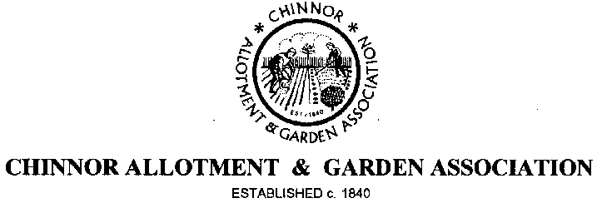

Annual General Meeting
8.00 PM Wednesday 9th October, 2019
The Chiltern Room
Chinnor Village Centre, High Street, Chinnor

The Association will be holding its Annual General Meeting as above and you are cordially invited. This is your opportunity to have your say, both complimentary and critical and to discuss how you would like to see the Association develop over the coming years. So please make every effort to attend.

Please find attached this year’s Agenda; the minutes of last year’s AGM are available for your inspection and can be found on our website.

Annual Plot rents become due from 1st October and you will be required to pay by the end of October 2019, otherwise your plot may be deemed vacant and re-let as we have an existing active waiting list, so please make every effort to visit the Distribution Centre any Sunday between 10.00 am and 12 noon before the end of October. You can pay at the AGM if this is more convenient.

This year there are vacancies for all three Officers - Chairman, Treasurer and Secretary. If you would like to be a more active member of the Association, why not volunteer to join the Committee and put your name forward. Voting for Chairman, Officers and Committee members takes place at the AGM. Nominations, in writing, need to be received by the Secretary before the start of the AGM. Nomination papers are available to download online from our website at www.caga.org.uk or from the Distribution Centre.

Please note that this year we will not be ordering potatoes on an individual pre-paid basis; some quantities of the more popular varieties will be available however from the Distribution Centre on a first come-first served basis.

We look forward to having a worthwhile and interesting AGM, made all the more so by your participation; afterwards you are invited to join the Committee for wine and nibbles.

CAGA Committee

